**3) What is the use of color and size options in the marks cart of tableau ? (With the help of**

**an example create one in tableau)**

In Tableau, the Marks card is a critical component for controlling how your data is represented in the view. The "Color" and "Size" options on the Marks card allow you to add an additional layer of information to your visualizations.

**Color:**

**1. Categorical Color:**

* When using a categorical (discrete) field for color, Tableau assigns different colors to distinct categories in your data. This is useful for distinguishing between different groups or categories.

**Steps:**

- Drag a categorical dimension (e.g., Product Category) to the "Color" shelf.

- Each category in the dimension will be assigned a unique color in the view.

**2. Continuous Color:**

* When using a continuous (numeric) field for color, Tableau creates a gradient or spectrum of colors based on the values in that field. This is useful for visualizing the distribution or trends in a numerical measure.

**Steps:**

- Drag a continuous measure (e.g., Sales) to the "Color" shelf.

- Tableau will apply a color gradient based on the range of values in the measure.

**3. Highlighting:**

* You can use color to highlight specific data points or subsets of your data. For example, you can use conditional formatting to color data points that meet certain criteria.

**Steps:**

- Right-click on a data point or axis and choose "Highlight" to emphasize specific elements in the view.

**Size:**

**1. Size by Measure:**

* Using size in the Marks card allows you to represent the magnitude of a measure using the size of the data points. Larger sizes typically represent higher values.

**Steps:**

- Drag a measure (e.g., Profit) to the "Size" shelf.

- Data points will vary in size based on the values in the measure.

**2. Size by Dimension:**

* You can also size data points based on a categorical dimension. This is useful for emphasizing the significance or volume of different categories.

**Steps:**

- Drag a dimension (e.g., Quantity) to the "Size" shelf.

- Data points will vary in size based on the values associated with each category.

**3. Dual-Axis with Size:**

* You can use both color and size simultaneously to add more layers of information to your visualization. For example, you can use color for one measure and size for another.

**Steps:**

- Place both the measure and dimension on the "Color" and "Size" shelves, respectively.

**4. Use in Combination with Other Fields:**

* Size can be used in combination with other fields, such as shapes, labels, or detail, to provide a more comprehensive view of your data.

**Steps:**

- Drag additional fields to the corresponding shelves (Label, Detail, etc.) to enhance your visualization.

In summary, the "Color" and "Size" options on the Marks card in Tableau provide powerful tools for encoding additional information into your visualizations, making it easier to identify patterns, trends, and insights in your data.

**In Tableau:**

**Prerequisites**: Superstore Data-source provided by Tableau, which includes three tables: orders, people, and returns.

**Orders Table**:

Columns: Order ID, Order Date, Ship Date, Ship Mode, Customer Name, Segment, Country/Region, City, State, Province, Category

**People Table**:

Columns: Regional Manager

**Returns Table**:

Columns: Returned

* For the created sheet below.
* We can change the color and size of the sheet.

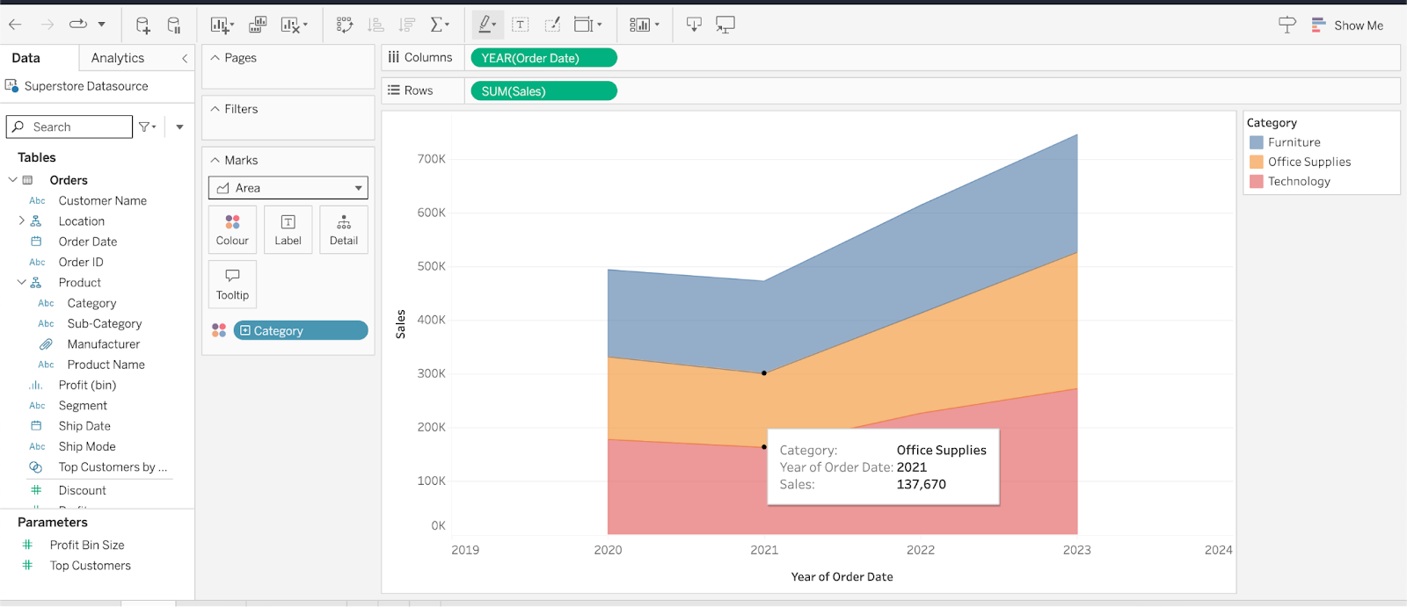

* We can change the color palette, opacity & border of the chart.

